Create your new project in VS
Close VS

Move the .sln and .suo files from your "My Documents\Visual Studio Projects" folder to the new Virtual directory.

Delete the project folder from your "My Documents\Visual Studio Projects"

Double click on the .sln file in the virtual directory to open VS

Create a new directory in file manager called Projects in new web site.

Using VS create the following Class Library projects (you can delete the class1 file) the location should be the new Projects directory:
BLL
Common
DALFactory
DALInterface
DALModel
DALOracle
DALSQLServer
Personalization

C:\Inetpub\wwwroot\CrossWalk\Projects for example

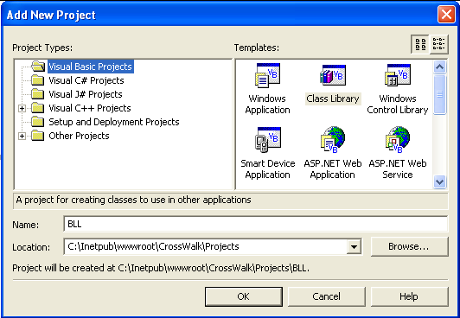

Setup the following reference:

Web project:
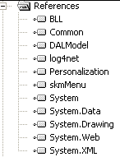

BLL:
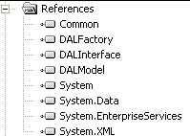

Common:
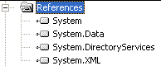

DALFactory:
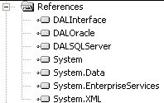

DALInterface:
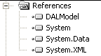

DALModel:
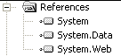

DALOracle:
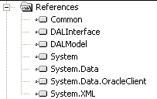

DALSQLServer:
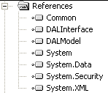

Personalization:
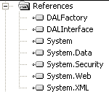
From each of the projects in the BaseApplication copy the system directories the web project will be different.

For the web project copy the following:
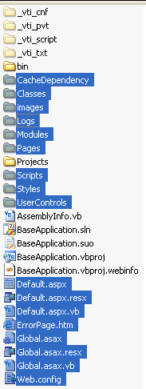

You can delete the Style.css file in your new project.

Use VS highlight your web project and click the show all files button:
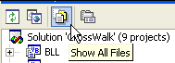

Highlight the following/right click on one of them and click “include in project”:
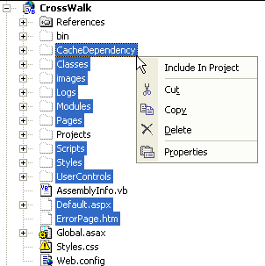

Repeat this process for all of the other project the only difference is the other projects should have just the system directory that you copied earlier.

Using the find and replace replace “BaseApplication” with your new solution name:

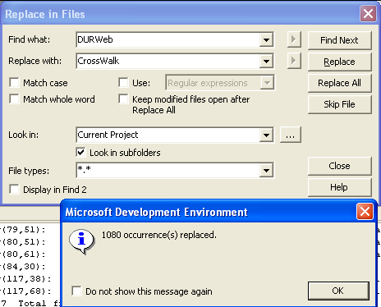

Edit the web.config file and ensure that all of the information in it is what you need for you application. Connection strings and the like will need to be changed to suit your needs.

If you are using NTFS for a file structure:
Using file manager locate the “CacheDependency” and set the security allowing the ASPNET account on your local machine “Modify” right. Do the same for “Logs”. You can also delete any unnecessary log files.

Set the default.aspx page as your startup page and try to run your new application.

